

ENGINEERING PROJECT MANAGEMENT - BUSA2302

**Prepared By:**

Salsabeel Hammoudeh 1180771

Yousra Qasem 1192131

Reem Salloum 1202160

Saja Aljamal

**Supervised By:** Dr.Sana' Atari

**First Semester**

**March 2023**

**Project initiation**

1. Project charter

|  |  |
| --- | --- |
| **1.0 Project Identification** | |
| **Name** | *Sakani* |
| **Description** | *A website and mobile app providing long-term rental services for student and staff housing in the West Bank.* |
| **Sponsor** | *Yousra Sheikh Qasim* |
| **Project Manager** | *Ahmad Mohammad* |

|  |
| --- |
| **2.0 PROJECT OBJECTIVES (PURPOSE)** |
| * Develop a website and mobile app for the Sakani project to cater to a wider audience * Provide detailed information about available rental properties, including location, 3D images, and pricing * Facilitate direct communication between housing owners and potential renters, without the need for a mediator * Generate revenue through advertising partnerships with service providers |

| **3.0 PROJECT SCOPE** |
| --- |
| * The Sakani Application will cover all student residences and staff housing in the West Bank. * The application will allow for the creation of three types of accounts: Housing Owner account, Buyer's account, and Advertising account |

| **4.0 KEY PROJECT DELIVERABLES** |
| --- |
| * A fully functional Sakani Application website and mobile app with user account creation and management system * A detailed database of available rental properties with location, 3D images, and pricing information * A direct communication system between housing owners and renters |

| **5.0 KEY PROJECT DELIVERABLES** |
| --- |
| * There will be sufficient demand for long-term rental housing in the West Bank * The application will be able to compete with existing rental options * Housing owners will be interested in showcasing their properties through the application |

| **6.0 MILESTONE DATES** | | | |
| --- | --- | --- | --- |
| **Item** | **Major Events / Milestones** | **Date Start** | **Date End** |
| 1. | Complete a research summary, Requirements gathering | 01-04-2023 | 08-04-2023 |
| 2. | Front-end website and app design | 08-04-2023 | 01-05-2023 |
| 3. | Development Process | 01-05-2023 | 05-06-2023 |
| 4. | Integration and testing | 05-06-2023 | 25-07-2023 |
| 5. | User Acceptability | 25-07-2023 | 10-08-2023 |
| 6. | Deployment to production | 10-08-2023 | 17-09-2023 |

|  |  |
| --- | --- |
| **7.0 BUDGET** | |
| Estimated budget for development | $142,800 |

| **8.0 ASSUMPTIONS** |
| --- |
| * There will be sufficient demand for long-term rental housing in the West Bank * The application will be able to compete with existing rental options * Housing owners will be interested in showcasing their properties through the application |

| **9.0 CONSTRAINTS** |
| --- |
| * Limited budget for development. * Limited availability of rental properties. * Legal and regulatory constraints related to housing rentals. |

|  |  |  |
| --- | --- | --- |
| **10.0 KEY STAKEHOLDERS** | | |
| **Name** | **Title** | **Email** |
| Yousra Sheikh Qasim | Project Sponsor | yousra@gmail.com |
| Saja Hussam | Project Manager | saja@gmail.com |
| Salsabeel Hammodeh | Mobile Development Team | salsabeel@gmail.com |
| Reem Salloum | Website Development Team | reem@gmail.com |
| Ahmad Yousef | Housing Owners | ahmad@gmail.com |
| Rana Ahmad | Renters | rana@gmail.com |
| Rama Yousef | Service Providers | rama@gmail.com |

|  |  |
| --- | --- |
| **11.0 RISKS** | |
| **Severity** | **Description** |
| 5% | Technical difficulties during development |
| 15% | Low adoption rate among potential renters |
| 10% | Limited availability of rental properties |
| 15% | Legal issues related to housing regulations |

| **12.0 SIGNOFF** |
| --- |
| Project Sponsor: yousra  Date: 04.03.2023 |
| Project Manager: saja  Date: 04.03.2023 |

1. Stakeholder Register

|  |  |  |  |
| --- | --- | --- | --- |
| **STAKEHOLDER REGISTER FOR SAKANI APPLICATION PROJECT** | | | |
| **Title** | **Stakeholder Role** | **Impact on the Project** | **Communication Plane** |
| Project Sponsor | Provides funding and supports for the project | High Impact | Regular meetings and progress reports |
| Project Manager | Oversees the project and ensure successful completion | High Impact | Regular meetings and progress reports |
| Mobile and Website Development Team | Develop the website and mobile app | High Impact | Daily stand-up meetings and weekly progress reports |
| Housing Owners | Provide rental properties for the application | High Impact | Regular communication though the application |
| Renters | Potential customers of the application | High Impact | Regular communication though the application |
| Service Providers | Advertise their services on the application | Medium impact | Regular communication though the application |
| Legal Team | Provides legal advice related to housing regulations | Medium impact | Regular meetings and progress reports |
| Marketing team | Promotes the application to potential renters and service providers | Low impact | Regular progress reports |

1. Kickoff meeting

|  |  |
| --- | --- |
| **KICKOFF MEETINGS** | |
| **Project Title : Sakani** | **Date : 01-01-2023** |
| **Project Manager : Yousra Sheikh Qasim** | **Location : Palestine** |
| 1. Welcome and Introductions    * Introduce the project team members and stakeholders    * Explain the purpose of the kickoff meeting | |
| 1. Project Overview    * Provide a high-level overview of the project goals and objectives    * Discuss the scope of the project and any potential challenges    * Present the project charter and ensure everyone is aligned with the project goals | |
| 1. Project Timeline and Deliverables    * Present the project timeline and milestones    * Discuss the deliverables and their expected completion dates    * Clarify any questions or concerns related to the timeline and deliverables | |
| 1. Roles and Responsibilities    * Discuss the roles and responsibilities of each team member    * Clarify any questions or concerns related to team member roles | |
| 1. Communication Plan    * Outline the communication plan for the project    * Discuss the frequency and format of communication between team members and stakeholders    * Clarify any questions or concerns related to communication | |
| 1. Project Risks and Mitigation Strategies    * Discuss potential risks and challenges related to the project    * Outline the mitigation strategies for each risk    * Assign responsible parties for risk mitigation | |
| 1. Project Scope and Requirements    * Discuss the project scope and requirements    * Review any changes or updates to the project requirements    * Clarify any questions or concerns related to the project scope and requirements | |
| 1. Next Steps    * Summarize the key takeaways from the meeting    * Discuss the next steps and action items for each team member    * Clarify any questions or concerns related to next steps | |
| 1. Wrap-up    * Thank the team members and stakeholders for their participation    * Confirm the date and time for the next meeting | |

**Project Planning**

1. WBS

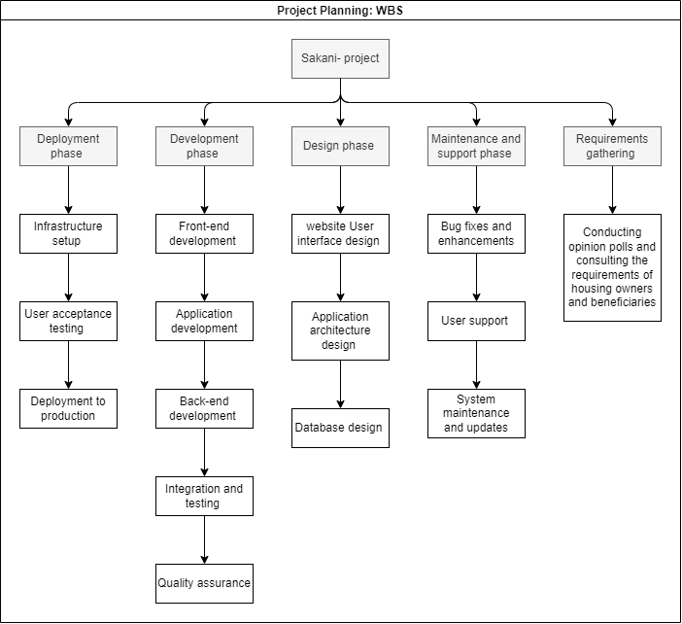

1. CPM

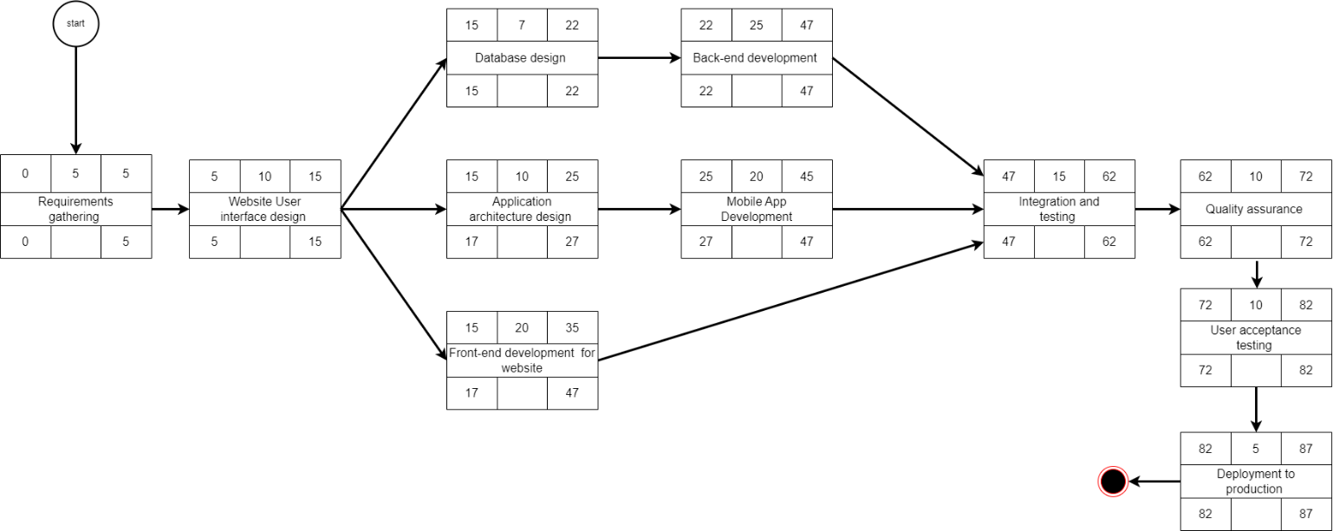

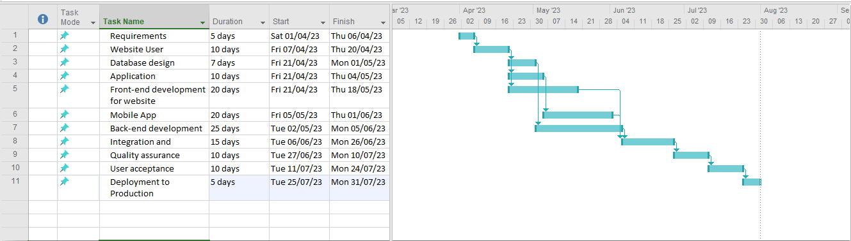

1. Cost and budget estimation form

|  |  |  |  |  |  |  |  |  |  |  |  |  |  |  |  |  |  |  |  |  |  |  |  |  |  |  |  |  |  |  |  |  |  |  |  |  |  |  |  |  |  |  |  |  |  |  |  |  |  |  |  |  |  |  |  |  |  |  |  |  |  |  |  |  |  |  |  |  |  |  |  |  |  |  |  |  |  |  |  |  |  |  |  |  |  |  |  |  |  |  |  |  |  |  |  |  |
| --- | --- | --- | --- | --- | --- | --- | --- | --- | --- | --- | --- | --- | --- | --- | --- | --- | --- | --- | --- | --- | --- | --- | --- | --- | --- | --- | --- | --- | --- | --- | --- | --- | --- | --- | --- | --- | --- | --- | --- | --- | --- | --- | --- | --- | --- | --- | --- | --- | --- | --- | --- | --- | --- | --- | --- | --- | --- | --- | --- | --- | --- | --- | --- | --- | --- | --- | --- | --- | --- | --- | --- | --- | --- | --- | --- | --- | --- | --- | --- | --- | --- | --- | --- | --- | --- | --- | --- | --- | --- | --- | --- | --- | --- | --- | --- | --- |
| **PROJECT ESTIMATION FORM**  **project description:** a website and mobile application that provides long-term rental services for student and staff housing in the west bank.  **Project manager:** Saja  **project start date:** 01-04-2023 **project end date**: 17-09-2023  total duration is about: **7 months**  Budget Actual Difference   |  |  |  |  |  | | --- | --- | --- | --- | --- | | personnel costs | Project Manager | 250$ per day | 250$ per day | 0 | | UI Designer | 90$ per day | 100$ per day | -10$ | | Website front-end developer | 100$ per day | 100$ per day | 0 | | Back-end developer | 120$ per day | 120$ per day | 0 | | Mobile Developer | 100$ per day | 100$ per day | 0 | | Database Administrator | 120$ per day | 120$ per day | 0 | | QA tester | 90$ per day | 100$ per day | -10$ | | total personnel costs | | 870$ x 22working day X 7 |  | - 3080$ | | equipment costs | server hosting | 100$ per month | 120$ per month | -20$ per month | | mobile devices | 1700$ | 1500$ | +200$ | | desktop computers | 1000$ x 7 = 7000$ | 900$ x 7 = 6300$ | +700$ | | total equipment costs | | 8800$ |  | +880$ | | software costs | Microsoft project | 100$ per month | 100$ per month | 0 | | Adobe creative suite | 100$ per month | 100$ per month | 0 | | total software costs | | 200$ per month |  | 0 | | other costs | marketing and advertising | 2500$ | 2000$ | +500$ | | legal fees | 1000$ | 900$ | +100$ | | office rent | 700$ per month X 7 | 700$ per month X 7 | 0 | | total other costs | | 10300 |  | +600$ |  |  |  | | --- | --- | | Budget estimation | | | personnel budget | 134,000$ | | equipment budget | 8,800$ | | software budget | 1,400$ | | other budget | 10,300$ | | total approved budget | 142,800$ |   approval: Saja  approved by: Yousra  date: 03-03-2023 |

1. Human Resources

This raci table can be used as a tool for assigning roles and responsibilities within the human resources team, and for clarifying who is responsible for what tasks in the recruitment and employee management process.

|  |  |  |  |  |
| --- | --- | --- | --- | --- |
| Activity |  |  | Team Member |  |
|  | Salsabeel | Saja | Reem | Yousra |
| Project Managing | C | R | I | I |
| Technical lead | R | A | C | I |
| Marketing lead | I | A | R | C |
| operations lead | I | A | I | R |

R => "responsible" refers to the person who is responsible for completing the task.

A=>"accountable" is the person who is ultimately responsible for the task's success.

C=> "consulted" are the individuals who provide input or advice on the task.

I=>"informed" are the individuals who need to be kept up-to-date on the task's progress

Hierarchical team organizational chart for "sakani" project

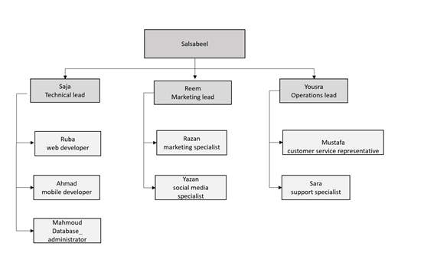

1. Quality plan

Here is an example quality plan for "sakani" system project:

1. quality objectives:
   * + to ensure that the "sakani" system meets or exceeds customer requirements and expectations.
     + To ensure that all aspects of the project are delivered on time, within budget, and with high quality.
     + To continuously improve the quality of the project deliverables and processes throughout the project lifecycle.
2. Quality control activities:
   * + regular reviews of project requirements, design, and code to ensure they meet quality standards.
     + Conducting unit testing, integration testing, and system testing to verify the functionality, performance, and security of the application.
     + Using automated testing tools to improve the efficiency and effectiveness of testing.
     + Conducting regular user acceptance testing to ensure that the application meets customer requirements and expectations.
     + Conducting regular code reviews to ensure that code is maintainable and follows coding standards.
3. Quality assurance activities:
   * + developing and maintaining a project quality plan to define quality objectives, standards, and processes.
     + Identifying and mitigating risks that could impact the quality of the project deliverables and processes.
     + Ensuring that all project team members are trained and equipped with the necessary tools and resources to achieve quality objectives.
     + Conducting regular quality audits to identify areas for improvement and ensure compliance with quality standards.
     + Providing regular feedback to the project team on quality performance and areas for improvement.
4. Quality standards:
   * + compliance with industry-standard coding practices and guidelines.
     + Adherence to security standards and best practices.
     + Compliance with customer requirements and expectations.
     + Use of best-in-class technologies and tools.
5. Quality metrics:
   * + defect density (number of defects per line of code)
     + test coverage (percentage of requirements covered by tests)
     + test effectiveness (number of defects found per test)
     + customer satisfaction (measured through surveys and feedback)
     + on-time delivery (percentage of deliverables delivered on time) by implementing this quality plan, your project team can ensure that the "sakani" system is delivered with high quality and meets or exceeds customer expectations.
6. risk plan

the project may face delays and budget overruns due to unforeseen technical issues or lack of resources . Here is a chart that categorizes the risk statement into external, internal (technical), and internal (non-technical) .

**summary of risk statements Sakani project**

**Internal Risks - Technical**

* Compatibility issues between the website and mobile application

* Security vulnerabilities in the application

* Performance issues due to high traffic volume

* Bugs and glitches in the application

**Internal Risks - Nontechnical**

* Lack of skilled human resources

* Insufficient funding

* Inadequate infrastructure

**External Risks - Unpredictable**

* Natural disasters

**Figure** Risk statement.

After categorizing the Risk , we are going to specify it in detail.

Here is the figure that shows the risk breakdown structure ( RBS ) that specifies all the risks that might face the project :

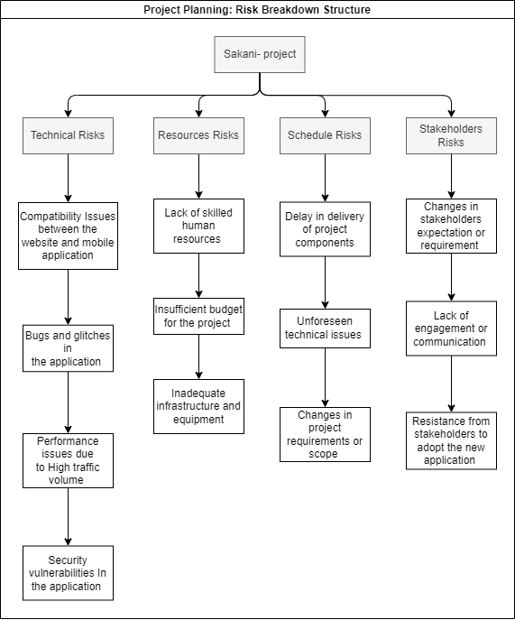

**Probability and Impact matrix :**

|  |  |  |  |
| --- | --- | --- | --- |
| Risk Title | | | |
|  | P | I | P X I |

|  |  |  |  |
| --- | --- | --- | --- |
| Compatibility  Issues between the website and mobile application. | | | |
| A | 0.03 | 0.2 | 0.006 |

|  |  |  |  |
| --- | --- | --- | --- |
| Lack of skilled human resources | | | |
| B | 0.5 | 0.2 | 0.1 |

|  |  |  |  |
| --- | --- | --- | --- |
| Delay in delivery of project components | | | |
| C | 0.15 | 0.2 | 0.03 |

|  |  |  |  |
| --- | --- | --- | --- |
| Changes in stakeholders expectation or requirement | | | |
| D | 0.02 | 0.1 | 0.002 |

|  |  |  |  |
| --- | --- | --- | --- |
| Bugs and glitches in the application | | | |
| E | 0.4 | 0.5 | 0.2 |

|  |  |  |  |
| --- | --- | --- | --- |
| Insufficient budget for the project | | | |
| F | 0.01 | 0.6 | 0.006 |

|  |  |  |  |
| --- | --- | --- | --- |
| Unforeseen technical issues | | | |
| G | 0.09 | 0.4 | 0.036 |

|  |  |  |  |
| --- | --- | --- | --- |
| Lack of engagement or communication | | | |
| H | 0.5 | 0.6 | 0.3 |

|  |  |  |  |
| --- | --- | --- | --- |
| Performance issues due to  High traffic volume | | | |
| I | 0.01 | 0.5 | 0.005 |

|  |  |  |  |
| --- | --- | --- | --- |
| Inadequate infrastructure  And equipment | | | |
| J | 0.2 | 0.1 | 0.02 |

|  |  |  |  |
| --- | --- | --- | --- |
| Changes in project requirements or scope | | | |
| K | 0.31 | 0.4 | 0.124 |

|  |  |  |  |
| --- | --- | --- | --- |
| Resistance from stakeholders to adopt the new application | | | |
| L | 0.33 | 0.1 | 0.033 |

|  |  |  |  |
| --- | --- | --- | --- |
| Security vulnerabilities  In the application | | | |
| M | 0.06 | 0.3 | 0.018 |

Probability

.50

0.3

0.03

0.124

0.006

0.036

0.1

0.002

0.005

0.006

0.2

0.033

0.018

0.02

0

.60

.50

.40

.30

.20

.10

.10

.20

.30

.40

Impact

Low Risk 0.001 – 0.009

Moderate Risk 0.1 – 0.19

High risk 0.2 – plus

**Project Execution**

**Team Charter**

**Purpose :** the purpose of the team is to develop and launch the sakani application that provides services in student housing and staff housing for long-term rental in the west bank .

**Goals :**

* Develop a user-friendly mobile application and website for the sakani project
* Create a database to store and manage housing owner and buyer information
* Develop a marketing strategy to promote the application
* Launch the application within the project timeline budget

**Roles and responsibilities :**

* Project manager
* Developers
* Database administrator
* Marketing specialist
* Quality assurance specialist

**Expectations :**

* Communications
* Accountability
* Collaboration
* Quality

**Signatures :**

We , the undersigned , agree to the above team charter and commit to working collaboratively to achieve the goals of the sakani application project

[project manager – Saja Hussam]

[Project sponsor – Yousra Sheikh Qasem]

[Mobile development – Salsabeel Hammoudeh]

[Website development – Reem Salloum]

[Renters - Rana Ahmad]

[Service providers – Rama Yousef]

[Housing owners – Ahmad Yousef]

**Project Monitoring**

To effectively monitor and control a project, it's important to regularly review its progress and make necessary adjustments. This involves establishing a baseline, setting up a project tracking system, holding regular status meetings with the team, updating the project plan, managing risks, ensuring quality, and managing stakeholders. By defining the project scope, schedule, budget, and quality standards in a project plan, a baseline is established for monitoring the project's progress and determining if it is on track. A project tracking system can be used to monitor key performance indicators, such as budget, schedule, quality, and risks. Regular status meetings should be scheduled to discuss progress, identify issues, and make decisions. The project plan should be updated accordingly if any changes are made to the project scope, schedule, budget, or quality standards. Risks should be identified and managed through a risk management plan, while quality should be monitored to ensure deliverables meet the project's standards. Effective communication with stakeholders is also important to keep them informed of the project's progress and address any concerns or issues they may have.